**Project Design Phase-I**

**Solution Architecture**

|  |  |
| --- | --- |
| Date | 19 September 2023 |
| Team ID | 0C3EDBD66A7F4ADA03A4EC3605388EAF |
| Project Name | |  | | --- | | Data Titans: Unearthing Trends from LinkedIn Influencers | |  | |
| Maximum Marks | 4 Marks |

**Solution Architecture:**

Solution architecture is a complex process – with many sub-processes – that bridges the gap between business problems and technology solutions. Its goals are to:

* Find the best tech solution to solve existing business problems.
* Describe the structure, characteristics, behaviour, and other aspects of the software to project stakeholders.
* Define features, development phases, and solution requirements.
* Provide specifications according to which the solution is defined, managed, and delivered.

**Example - Solution Architecture Diagram:**

**Reference:** https://www.google.com/url?sa=i&url=https%3A%2F%2Fwww.researchgate.net%2Ffigure%2FArchitecture-of-the-proposed-Big-Data-analytics-integration-solution_fig7_324596564&psig=AOvVaw3u0Uo2YEcUMPrZN0l3Kl0m&ust=1698942778337000&source=images&cd=vfe&opi=89978449&ved=0CBIQjRxqFwoTCKjd85ido4IDFQAAAAAdAAAAABAJ

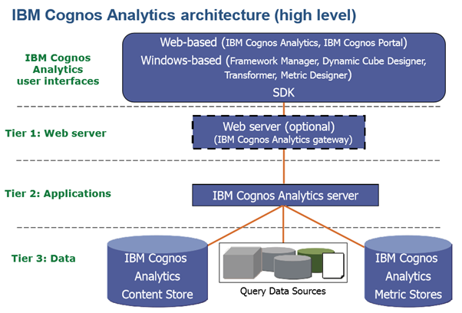

*Figure 1: Architecture and data flow*